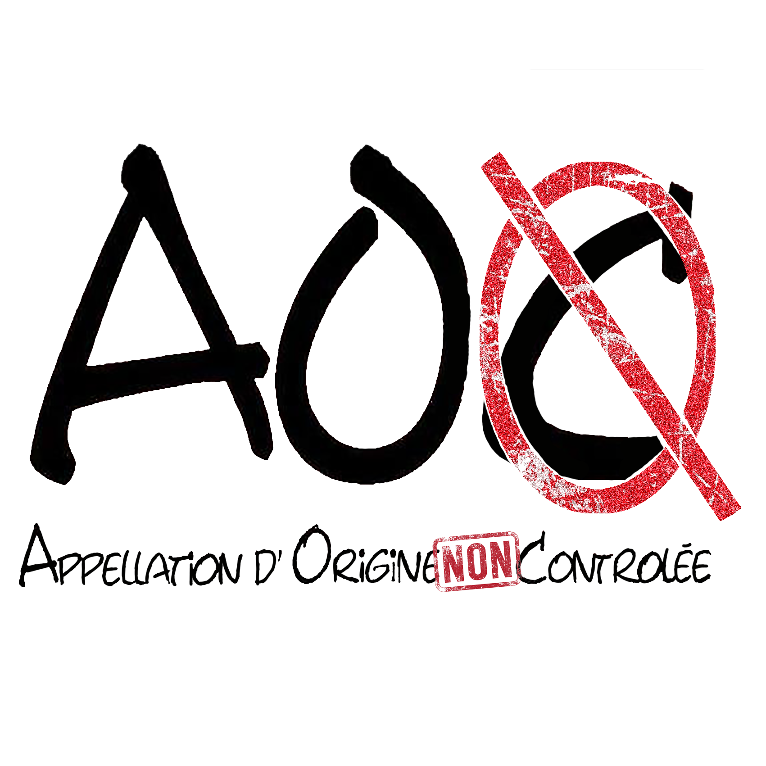
SETLIST AOC 2018

Another Brick in the Wall (Pink Floyd)
Shut up and Dance (Walk the Moon)
The show must go On (Quenn)
I Want to Break Free (Queen)
Born to be Wild (Steppenwolf)
It’s my Life (Bon Jovi)
Superstition (Stevie Wonder)
Proud Mary (Tina Turner)
Hotel California (Eagles)
Eteins la lumière (Axel Bauer)
Raisonne (Aston Villan)
La sentinelle (Luke)
Medley Goldman
Medley Johnny
Basket Case (Green Day)
East Jesus Now here (Green Day)
Wake me up when September Ends (Green Day)
My Sharona (The Knack)
Don’t look back in Anger (Oasis)
Little Wing (Hendrix)
Vertigo (U2)
With or Wihout you (U2)
Are you gonna go my way (Lenny Kravitz)
Time is running out (Muse)
Ca c’est vraiment toi (Téléphone)
Un autre monde (Téléphone)
Au cœur de la nuit (Téléphone)
Still got the Blues (Gary Moore)
Creep (Radiohead)
All right Now (Free)
Honky Tonk Women (The Rolling Stones)
Dani California (Red Hot Chili Peppers)
Gimme all your lovin’ (ZZ Top)
Tush (ZZ Top)
Whatever you want (Status Quo)
Anti Social (Trust)
Still loving you (Scorpion)
Sweet Child O’Mine (Guns N’ Roses)
Zombie (The Cranberries)

